Heritage LMI Toolkit

modular survey template

THE INSTITUTE OF CONSERVATION – HISTORIC ENGLAND – CHARTERED INSTITUTE FOR ARCHAEOLOGISTS

Created 2019 – Published 2020

Copyright
This publication is © The Institute of Conservation and is released under a CC BY-NC-ND 4.0 license: Creative Commons Attribution-NonCommercial-NoDerivatives 4.0 International

Acknowledgements
The Institute of Conservation and Loud Marketing undertook this project in 2019 in partnership with the Chartered Institute for Archaeologists and Historic England. It was funded by Historic England and supported by Historic Environment Scotland and Cadw.

The Project Team comprised Susan Bradshaw, Anni Mäntyniemi, Patrick Whife, Kate Geary and Stephen O’Reilly.

The Project Team would like to thank the following individuals for their direct contributions to the project: Edmund Lee, Jenni Butterworth, Jill Fairweather, Karyn McGhee, Helen Lloyd, Rebecca Hellen and Christina Rozeik.

Developed by:

Cover page by: Anni Mäntyniemi
Funded by:

Delivered by:

Contents

Introduction 2
How to use the template 2
The Template 4
Introductory text for your LMI survey 4
Validation statement 5
Module 1: About your organisation 7
Module 2: About your workforce 14
Module 3: Demographics 29
Module 4: Educational attainment and professional accreditation 39
Module 5: Skills 45
Module 6: Salary and benefits 53
Module 7: International workforce 60
Appendix 1 67

Introduction
The Institute of Conservation has partnered with the Chartered Institute for Archaeologists and Historic England to develop this Heritage LMI Toolkit (the Toolkit) to enable the collection, analysis and reporting of labour market information and labour market intelligence across the heritage space. In the context of this Toolkit, the heritage space is an umbrella term for the sectors and subsectors of the economy that could reasonably be deemed to be concerned, solely or in part, with heritage.

The Modular Survey Template should be read in conjunction with our Heritage LMI Toolkit guidance and instructions, which include guidelines for using this template and best practice advice for undertaking labour market research.

The Modular Survey Template allows you to create a balanced and reliable survey. The Template comprises:

- Introductory text for your LMI survey
- Validation statement
- Module 1: About your organisation
- Module 2: About your workforce
- Module 3: Demographics
- Module 4: Educational attainment and professional accreditation
- Module 5: Skills
- Module 6: Salary and benefits
- Module 7: International workforce

How to use the template

In each module you will find:

- Page title text
- Introductory text where applicable
- Question text
- Answer option text
- Question type information – e.g. single answer, multi answer, etc
- Explanatory notes for your respondents, where applicable
- Toolkit user notes, for you, where applicable

Some of the text are additional notes to help you set up the question, while some of it is for you to directly copy and paste into your online LMI survey platform. Text for you to copy and paste into your survey is shown indented, in Arial 12-point font, in grey shading. Text that you need to fill in is shown in square brackets. User notes are displayed in Calibri 12-point font.

The sections of a typical module are explained below.
Module 1

Page title for Module 1:

Copy and paste this text as the ‘Title’ for your module of your chosen online survey platform.

Introduction for Module 1:

Copy and paste this text as the ‘Page Description’ in your chosen online survey platform [WITH ADDITIONAL INFORMATION HERE IF REQUIRED]

Question 1 Module 1

Copy and paste this text for the question.

Answer options text:

Copy and paste this text for the question’s answer options.

Question type: Choose this as the type of question e.g. single answer, multi answer, etc.

Explanatory notes:

Copy and paste this text where applicable as explanatory notes to help your respondents answer the question.

Toolkit User notes:

Additional information to help you set up the question. You do not need to copy and paste this text.

The Template

Introductory text for your LMI survey

Page title for introductory page:

Introduction

Introductory text for your LMI survey:

This is a Labour Market Intelligence survey of the [ENTER SECTOR OR SUBSECTOR] workforce.

The survey contains a series of questions about your workforce, e.g. age, location, role, qualifications and skills. We will ask questions about your workforce as a whole. We will also ask questions about the subset of your entire workforce with specialist heritage skills. In this survey we will refer to them as your ‘specialist heritage skills workforce’.

The raw data and information generated through your answers to this survey will be analysed and interpreted. Through this process we will generate labour market intelligence (LMI). This LMI will be used to help understand the [ENTER SECTOR OR SUBSECTOR] workforce, how it is changing, and where the challenges and opportunities are. This LMI will then be shared across the heritage sector via Historic England.

The Institute of Conservation (Icon) has partnered with the Chartered Institute for Archaeologists (CIfA) and Historic England to develop a Heritage LMI Toolkit to enable the collection, analysis and reporting of LMI within the heritage sector. This survey has been created using the Heritage LMI Toolkit. The Heritage LMI Toolkit is available to heritage organisations, empowering them to independently conduct workforce research on a regular basis. The broader objective is to support the development and sustainability of the heritage workforce and to inform policy and decision-making affecting it.

Toolkit user notes regarding the introductory text:

- You may wish to include this introductory text at the beginning of your LMI survey or in other places where you think it will be helpful, for example in an email invitation.
- Creating an ‘intro page’ is a good idea so respondents read the introductory text first.
- In your LMI survey, you may wish to give the introductory text a title.
- We recommend that you include a confidentiality and privacy statement that aligns with your own data protection policies. This statement should inform potential respondents that the data would be shared across the heritage sector via Historic England.

Validation statement

Page title for the validation statement:

Validation statement

Validation statement text:

My organisation currently operates in the [ENTER NAME] sector, or I operate in this sector as a self-employed person.

Answer options to the validation statement:

Agree
Disagree

Validation statement question type: Agree / Disagree

Explanatory notes for validation statement:

The following validation statement is designed to ensure that this survey is right for you. Please agree or disagree to continue.

Toolkit user notes regarding the validation statement:

- You must include this validation statement.
- It is compulsory and ensures the heritage workforce is the focus of your survey.
- Include the validation statement as question 1 of your survey.
- You can replace ‘[ENTER NAME]’ in the validation statement with the name of your sector or subsector, e.g. ‘archaeology’’ or ‘heritage’.
- If a respondent chooses “Agree” as their answer they will proceed to the survey.
- If a respondent disagrees, the survey will close. We recommend that when the survey closes, these respondents receive a message thanking them for their interest. This is often called a ‘custom disqualification’ message and can be amended from the standard message in the settings of your chosen online survey platform.
- You may wish to include some explanatory notes for respondents regarding the validation statement, for example; ‘Please read the statement below and choose ‘Agree’ or ‘Disagree’. This is so we can ensure this survey is right for you.’

Module 1: About your organisation

Page title for Module 1:

About your organisation

Introduction for Module 1:

The following questions will provide us with an overview of your organisation. You may need to find data or information in order to complete the questions. You can come back to the survey multiple times if you wish, as your answers will be saved. Please do not guess the answers. It is better that you choose “Don’t know” if you are unsure of any answer.

Question 1 Module 1:

What type of organisation do you represent? Please tick all that apply.

Answer options for Question 1 Module 1:

Central government organisation
Central government organisation sub-unit
Local government organisation
Local government organisation sub-unit
Non-departmental public body
Non-departmental public body sub-unit
Charity
Private limited company
Public limited company
Social enterprise
University or other education institution
University or other education sub-unit
I am a freelancer
I am a sole proprietor or sole trader
Don’t know
Other, please specify

Question 1 Module 1 question type: Checkboxes multi choice

Question 2 Module 1:

What is your Standard Industry Classification (SIC) code?

Answer options for Question 2 Module 1:

94990 Activities of other membership organisations
94120 Activities of professional membership organisations
71111 Architectural activities
91012 Archive activities
91040 Botanical & zoological gardens & nature reserves activities
43990 Building completion and finishing
41201 Construction of commercial buildings
41202 Construction of domestic buildings
42990 Construction of other civil engineering projects
41100 Development of building projects
71122 Engineering related scientific & technical consulting activities
74901 Environmental consulting activities
85421 First-degree level higher education
84110 General public administration activities
81300 Landscape service activities
91011 Library activities
70229 Management consultancy activities other than financial management
68320 Management real estate on fee or contract basis
91020 Museums activities
91030 Operation of historical sites & similar visitor attractions
93290 Other amusement & recreational activities
71129 Other engineering activities
72190 Other research & experimental development on natural sciences & engineering
43999 Other specialised construction activities
74902 Quantity surveying activities
68310 Real estate agencies
84120 Regulation of health care, education, cultural & other social services
68201 Renting & operating Housing Association real estate
71112 Urban planning & landscape architectural activities
Don’t know
Prefer not to say
Other, please specify

Question 2 Module 1 question type: Single choice

Explanatory notes for Question 2 Module 1:

A SIC code is a five-digit number used to categorise the principal business activities of limited companies and other organisations operating within the UK. It is helpful here because the data in your answers can then be compared with other respondents with the same SIC code. If your organisational activity is not listed here, you can visit http://resources.companieshouse.gov.uk/sic/ to look up SIC codes on the Companies House website. You can then enter the code in the ‘Other’ answer field.

Question 3 Module 1:

What is the total turnover of your organisation?

Answer options for Question 3 Module 1:

Less than £81,000
£81,000 - £99,999
£100,000 - £249,999
£250,000 - £499,999
£500,000 - £999,999
£1m – £1.99m
£2m - £2.8m
£2.81m - £4.99m
£5m - £9.99m
£10m - £14.99m
£15m - £24.99m
£25m or more
Don’t know
Prefer not to say
N/A

Question 3 Module 1 question type: Single choice

Explanatory notes for Question 3 Module 1:

Turnover is defined as the total value of sales. This is calculated by adding together the values of sales of goods produced, goods purchased and resold without further processing, work done and industrial services rendered and non-industrial services rendered. If your organisation does not have a readily calculable turnover figure, please choose N/A.

Question 4 Module 1:

What proportion of your organisation’s total resources is spent working on heritage projects or heritage aspects of larger projects?

Answer options for Question 4 Module 1:

None
Less that 10%
10% to 19%
20% to 29%
30% to 39%
40% to 49%
50% to 59%
60% to 69%
70% to 79%
80% to 89%
90% or more
Don’t know
Prefer not to say

Explanatory notes for Question 4 Module 1:

We use the term ‘total resources’ because you may allocate one of more of the following: workforce time (human resources), money (capital resources), plant and equipment, facilities, etc.

Question 4 Module 1 question type: Single choice

Toolkit user notes for Question 4 Module 1:

- You may wish to include a definition of ‘heritage projects’.
Our definition is ‘a heritage project is any carefully planned enterprise, activity or task designed to achieve a particular aim regarding the investigation, protection, preservation, conservation, renovation, restoration or development of immovable and moveable physical objects, landscapes, artefacts and intangible attributes, practices or characteristics of a country or society’.

Question 5 Module 1:

In which of these geographic areas do you operate? Please tick all that apply.

Answer options for Question 5 Module 1:

North East England
North West England
Yorkshire and The Humber
East Midlands
West Midlands
East of England
London
South East England
South West England
Scotland
Wales
Northern Ireland
Europe outside of the UK
Outside Europe

Question 5 Module 1 question type: Checkboxes multi choice

Question 6 Module 1:

Do you have any other comments?

Answer options for Question 6 Module 1: Free text answer

Question 6 Module 1 question type: Comment box

Module 2: About your workforce

Page title for Module 2:

About your workforce

Introduction for Module 2:

The following questions will provide us with an overview of the workforce in your organisation. You should include self-employed people and subcontractors as part of your workforce, i.e. as if they were employees, if you use them on a regular basis. You may need to find data or information in order to complete the questions. You can come back to the survey multiple times if you wish, as your answers will be saved. Please do not guess the answers. It is better that you choose “Don’t know” if you are unsure of any answer.

Toolkit user notes for Module 2:

- This text provides more information for your respondents about the Module and the questions in it. You can copy and paste this text as the ‘Page Description’ in your chosen online survey platform.
- Ideally, your chosen online survey platform will enable your respondents to return to your LMI survey multiple times. This will make it easier for them to complete your LMI survey as, for example, they may need to consult with others or find out information that is not readily available to them.

Question 1 Module 2:

How many people made up your organisation’s total workforce, including self-employed people and subcontractors, on [ENTER DATE]?

Answer options for Question 1 Module 2: None

Question 1 Module 2 question type: Single text box, numerical data only allowing two decimal places

Explanatory notes for Question 1 Module 2:

Two decimal places are available in the answer to this question to allow for part-time staff, self-employed people and subcontractors. You should include self-employed people and subcontractors as part of your workforce, i.e. as if they were employees, if you use them regularly. If you are self-employed and you operate alone, your answer should be 1.00.

Toolkit user notes for Question 1 Module 2:

- Please replace [ENTER DATE] with an appropriate date, e.g. 31 December or the end of your financial year.
- Allow a numerical answer only. You want your respondents to enter a number in the text box.

Question 2 Module 2:

How many people make up your organisation’s specialist heritage skills workforce, including self-employed people and subcontractors, on [ENTER DATE]?

Answer options for Question 2 Module 2:

1 as I am self-employed or a sole trader
2-9
10-19
20-49
50-99
100-249
250 or more
Don’t know
Prefer not to say

Question 2 Module 2 question type: Single choice

Explanatory notes for Question 2 Module 2:

A person has ‘specialist heritage skills’ if they concentrate primarily on a particular heritage subject, activity or specific and restricted field and are demonstrably knowledgeable and experienced in that subject. In this survey, the people within your organisation who have specialist heritage skills will be referred to as your ‘specialist heritage skills workforce’.

You should include self-employed people and subcontractors as part of your workforce, i.e. as if they were employees, if you use them regularly.

Question 3 Module 2:

Which of the following occupations does your organisation employ?

Answer options for Question 3 Module 2:

SOC 2141 Conservation professionals
SOC 2431 Architects
SOC 2432 Town planning officers
SOC 2434 Chartered surveyors
SOC 3114 Building and civil engineering technicians
SOC 2912 Archaeologists
SOC 2452 Archivists and curators
Don’t know
Prefer not to say
Other, please specify

Question 3 Module 2 question type: Checkboxes multi answer

Explanatory notes to Question 3 Module 2:

The occupations listed use Standard Occupational Classification codes, a common classification of occupational information for the UK. If your organisation employs people with occupations that are not listed, you can visit https://www.ons.gov.uk/methodology/classificationsandstandards/standardoccupationalclassificationsoc to look up SOC codes and add them in the other field.

Question 4 Module 2:

How many people in your organisation’s specialist heritage skills workforce are employed in each of the following ways? Please enter figures in the boxes provided.

Answer options for Question 4 Module 2:

Employed – full-time permanent contract
Employed – part-time permanent contract
Employed – full-time fixed term contract more than 12 weeks
Employed – part-time fixed term contract more than 12 weeks
Employed – full-time fixed term contract less than 12 weeks
Employed – part-time fixed term contract less than 12 weeks
Employed – zero hours contract
Self-employed, sole proprietors and sole traders, freelancers
Other subcontractors
Don’t know
Prefer not to say

Question 4 Module 2 question type: Multiple text boxes, numerical data only

Explanatory notes for Question 4 Module:

Both freelancers and sole traders are likely to refer to themselves as self-employed. A sole trader is defined by its business structure, but a freelancer may choose how they operate. In this context, all three terms refer to individuals (not businesses) who are not employed by your organisation but do work for you organisation in some capacity, on a regular basis. Businesses that act in a similar way are subcontractors.

Toolkit user notes for Question 4 Module 2:

- Allow a numerical answer only. You want your respondents to give a number in each text box alongside the employment type answer options listed above.

Question 5 Module 2:

How many people in your organisation’s specialist heritage skills workforce have the following roles? Please enter figures in the boxes provided.

Answer options for Question 5 Module 2:

Director
Senior manager
Manager
Practitioner / technician or similar role
Assistant or similar entry-level role
Trainee
Prefer not to say
Don’t know

Question 5 Module 2 question type: Multiple text boxes, numerical data only

Toolkit user notes for Question 5 Module 2:

- Allow a numerical answer only. You want your respondents to give a number in each text box alongside the role answer options listed above.

Question 6 Module 2:

Do you have any apprentices?

Answer options for Question 6 Module 2:

Yes
No
Don’t know
Prefer not to say

Question 6 Module 2 question type: Single choice

Explanatory notes for Question 6 Module 2:

Only those currently registered to study to an approved apprenticeship standard should be included as ‘Apprentice’. Approved lists can be found at:
https://www.instituteforapprenticeships.org/apprenticeship-standards/
https://www.apprenticeships.scot
https://gov.wales/apprenticeships-skills-and-training

Question 7 Module 2

Thinking about your organisation’s workforce with specialist heritage skills, what was the employee turnover rate, as a percentage, over the past year?

Answer options for Question 7 Module 2:

Less than 5%
Between 6% and 10%
Between 11% and 15%
Between 16% and 20%
More than 20%
Don’t know
Prefer not to say

Question 7 Module 2 question type: Single choice

Explanatory notes for Question 7 Module 2:

You can calculate your employee turnover rate like this:
Number of leavers over the past year
X 100%
Average number of employees during the year

Question 8 Module 2

What is the likelihood of your organisation increasing or decreasing its specialist heritage skills workforce over the coming year?

Answer options for Question 8 Module 2

Very likely to increase
Likely to increase
Don’t know
Likely to decrease
Very likely to decrease
Prefer not to say

Question 8 Module 2 question type: Rating scale

Question 9 Module 2:

Has your organisation recruited anyone with specialist heritage skills in the last 12 months?

Answer options for Question 9 Module 2:

Yes
No
Don’t know
Prefer not to say

Question 9 Module 2 question type: Single choice

Question 10 Module 2

If you had any vacancies for workers with specialist heritage skills in the last 12 months, were any of these vacancies hard to fill?

Answer options:

Yes
No
Don’t know
Prefer not to say
N/A

Question 10 Module 2 question type: Single choice

Question 11 Module 2:

If you found it hard to fill a vacancy for a worker with specialist heritage skills, what were the main reasons for this? Please tick all that apply.

Answer options for Question 11 Module 2:

Too much competition from other employers
Not enough people interested in doing this type of job
Poor terms and conditions (e.g. pay) offered for post
Low number of applicants with the required skills
Low number of applicants with the required attitude, motivation or personality
Low number of applicants generally
Lack of work experience the company demands
Lack of qualifications the company demands
Poor career progression/lack of prospects
Job entails shift work/unsociable hours
Seasonal work
Remote location/poor public transport
Brexit
No particular reason
Don’t know
Prefer not to say
N/A
Other, please specify

Question 11 Module 2 type: Checkboxes multi answer

Question 12 Module 2:

Please explain in more detail any recruitment or retention challenges you have for your specialist heritage skills workforce, including details of any specific roles.

Answer options for Question 12 Module 2: Free text answer

Question 12 Module 2 question type: Comment box

Question 13 Module 2:

How many people have volunteered for your organisation in the past year?

Question 13 Module 2 question type: Single text box, numerical data only

Toolkit user notes for Question 13 Module 2:

- Allow a numerical answer only. You want your respondents to enter a number in the text box.

Question 14 Module 2:

Do you have any other comments?

Answer options for Question 14 Module 2: Free text answer

Question 14 Module 2 question type: Comment box

Module 3: Demographics

Page title for Module 3:

Demographics

Introduction for Module 3:

Demographic questions help us understand the workforce in our sector. They provide information that helps employers to meet their legal duties under equalities legislation and improve accessibility for prospective employees. It is important that you know this type of information is only collected when necessary. All information collected is anonymised and confidential.

If you are self-employed, a sole proprietor or sole trader, the following questions are about you personally, so select 100% for the appropriate answer option.

You may need to find data or information in order to complete the questions. You can come back to the survey multiple times if you wish, as your answers will be saved. Please do not guess the answers. It is better that you choose “Don’t know” if you are unsure of any answer.

Toolkit user notes for Module 3:

- Ideally, your chosen online survey platform will enable your respondents to return to your LMI survey multiple times. This will make it easier for them to complete your LMI survey as, for example, they may need to consult with others or find out information that is not readily available to them.

Question 1 Module 3:

How many people in your organisation’s specialist heritage skills workforce are in the following age bands? Please enter figure in the boxes provided.

Answer options for Question 1 Module 3:

16-24
25-34
45-54
55-64
65+
Don’t know
Prefer not to say

Question 1 Module 3 question type: Multiple text boxes, numerical data only

Toolkit user notes for Question 1 Module 3:

- Allow a numerical answer only. You want your respondents to give a number in each text box alongside the role answer options listed above.

Question 2 Module 3:

How many people in your organisation’s specialist heritage skills workforce have the following gender? Please enter figures in the boxes provided.

Answer options for Question 2 Module 3:

Male
Female
Other
Don’t know
Prefer not to say

Question 2 Module 3 question type: Multiple text boxes, numerical data only

Toolkit user notes for Question 2 Module 3:

- Allow a numerical answer only. You want your respondents to give a number in each text box alongside the role answer options listed above.

Question 3 Module 3:

How many people in your organisation’s specialist heritage skills workforce are in the following ethnic groups? Please enter figures in the boxes provided.

Answer options for Question 3 Module 3 for England only:

White
English / Welsh / Scottish / Northern Irish / British
Irish
Gypsy or Irish Traveller
Any other White background

Mixed / Multiple ethnic groups
White and Black Caribbean
White and Black African
White and Asian
Any other Mixed / Multiple ethnic background

Asian / Asian British
Indian
Pakistani
Bangladeshi
Chinese
Any other Asian background

Black / African / Caribbean / Black British
African
Caribbean
Any other Black / African / Caribbean background

Other ethnic group
Arab
Any other ethnic group

Don’t know
Prefer not to say

Answer options for Question 3 Module 3 for Wales only:

White
Welsh / English / Scottish / Northern Irish / British
Irish
Gypsy or Irish Traveller
Any other White background

Mixed / Multiple ethnic groups
White and Black Caribbean
White and Black African
White and Asian
Any other Mixed / Multiple ethnic background

Asian / Asian British
Indian
Pakistani
Bangladeshi
Chinese
Any other Asian background

Black / African / Caribbean / Black British
African
Caribbean
Any other Black / African / Caribbean background

Other ethnic group
Arab
Any other ethnic group

Don’t know
Prefer not to say

Answer options for Question 3 Module 3 for Scotland only:

White
White Scottish
Other White British
White Irish
Gypsy / Traveller
White Polish
Any other White background

Mixed or multiple ethnic group
Any mixed or multiple ethnic groups

Asian, Asian Scottish or Asian British
Pakistani, Pakistani Scottish or Pakistani British
Indian, Indian Scottish or Indian British
Bangladeshi, Bangladeshi Scottish or Bangladeshi British
Chinese, Chinese Scottish or Chinese British
Any other Asian background

African
African, African Scottish or African British
Other
Caribbean or Black
Caribbean, Caribbean Scottish or Caribbean British
Black, Black Scottish or Black British

Other
Other ethnic group
Arab, Arab Scottish or Arab British
Any other ethnic group

Don’t know
Prefer not to say

Answer options for Question 3 Module 3 for Northern Ireland only:

White
Chinese
Irish Traveller
Indian
Pakistani
Bangladeshi
Black Caribbean
Black African
Black Other
Mixed ethnic group
Any other ethnic group

Answer options for Question 3 Module 3, UK-wide:

White
Irish Traveller
Mixed/ Multiple ethnic groups
Asian/ Asian British
Indian
Pakistani
Bangladeshi
Chinese
Any other Asian background
Black/ African/ Caribbean/ Black British
Other ethnic group
Arab
Any other ethnic group

Question 3 Module 3 question type: Multiple text boxes, numerical data only

Toolkit user notes for Question 3 Module 3:

- Allow a numerical answer only. You want your respondents to give a number in each text box alongside the role answer options listed above.
- Choose the answer options that are appropriate to your region.

Question 4 Module 3:

How many people in your organisation’s specialist heritage skills workforce have the following nationalities? Please enter figures in the boxes provided.

Answer options for Question 4 Module 3:

UK national
EU national other than UK
Non-EU European national
Canadian or US national
South American national
African national
Asian national
Australasian national

Question 4 Module 3 question type: Multiple text boxes, numerical data only

Toolkit user notes for Question 4 Module 3:

- Allow a numerical answer only. You want your respondents to give a number in each text box alongside the role answer options listed above.

Question 5 Module 3:

How many people in your organisation’s specialist heritage skills workforce consider himself or herself to have a disability or learning disorder? Please enter figures in the boxes provided.

Question 5 Module 3 question type: Single text box, numerical data only

Toolkit user notes for Question 5 Module 3:

- Allow a numerical answer only. You want your respondents to give a number in the text box.

Question 6 Module 3:

Do you have any other comments?

Answer options for Question 6 Module 3: Free text answer

Question 6 Module 3 question type: Comment box

Module 4: Educational attainment and professional accreditation

Page title for Module 4:

Educational attainment and professional accreditation

Introduction for Module 4:

In this section we want to find out about the level of educational attainment and professional accreditation needed to work for your organisation. We will ask about your organisation’s employees as a whole, your organisation’s specialist heritage skills workforce and about [ENTER NAME OF SPECIALISM].

You may need to find data or information in order to complete the questions. You can come back to the survey multiple times if you wish, as your answers will be saved. Please do not guess the answers. It is better that you choose “Don’t know” if you are unsure of any answer.

Toolkit user notes for Module 4:

- Ideally, your chosen online survey platform will enable your respondents to return to your LMI survey multiple times. This will make it easier for them to complete your LMI survey as, for example, they may need to consult with others or find out information that is not readily available to them.

Question 1 Module 4:

The educational attainment of your specialist heritage skills workforce.

Items to evaluate in Question 1 Module 4:

Entry-level educational attainment for all your employees
Entry-level educational attainment for your specialist heritage skills workforce
Entry-level educational attainment for [ENTER NAME OF SPECIALISM]
Most common educational attainment for all your employees
Most common educational attainment for your specialist heritage skills workforce
Most common educational attainment for [ENTER NAME OF SPECIALISM]

Answer options for Question 1 Module 4 for England, Wales and NI:

Entry-level
Level 1, e.g. NVQ Level 1 or GCSE grades 1 to 3
Level 2, e.g. NVQ Level 2 or GCSE grades 4 to 9
Level 3, e.g. A Level
Level 4, e.g. HNC, NVQ Level 4
Level 5, e.g. HND
Level 6, e.g. Bachelor’s degree
Level 7, e.g. Master’s degree
Level 8, e.g. PhD
Don’t know
Prefer not to say
Other, please specify

Answer options for Question 1 Module 4 for Scotland:

Levels 1-3
Level 4, SVQ Level 1
Level 5, SVQ Level 2
Level 6, e.g. Higher
Level 7, e.g. Advanced Higher
Level 8, e.g. HND
Level 9-10, e.g. Bachelor’s degree
Level 11, e.g. Master’s degree
Level 12, e.g. PhD
Don’t know
Prefer not to say
Other, please specify
Question 1 Module 4 question type: Matrix of dropdowns

Toolkit user notes for Question 1 Module 4:

- You can use this question to find out the qualifications of different ‘specialists’ in your sector / subsector. You can repeat this question for each specialism if you wish. We suggest you limit the number of specialisms so that the question is not too complex. Examples of a specialism in this context are Paper Conservator or Marine Archaeologist.
- A matrix of dropdown menus questions allows respondents to evaluate several items using the same set of measurements by choosing from a pre-set list of answer choices. The matrix is made up of the items to evaluate as rows and the answer choices as a column.
- The items to evaluate listed above should be displayed as rows. A single column of dropdown menus next to each row should include the answer options listed above relevant to your respondent’s home nation. As you will have only a single column, the dropdown in it will be the same for each row.
- Please see Appendix 1 (pp. 67-70) where we have included some screen grabs from Survey Monkey to show how a matrix of dropdowns question type would look in a live survey.
- Choose the answer options that are appropriate to your region.

Question 2 Module 4:

The professional accreditation of your specialist heritage skills workforce.

Items to evaluate in Question 2 Module 4:

Entry-level professional accreditation for all your employees
Entry-level professional accreditation for your specialist heritage skills workforce
Entry-level professional accreditation for [ENTER NAME OF SPECIALISM]
Most common professional accreditation for all your employees
Most common professional accreditation for your specialist heritage skills workforce
Most common professional accreditation for [ENTER NAME OF SPECIALISM]

Answer choices for Question 2 Module 4:

[ENTER PROFESSIONAL ACCREDITATION 1]
[ENTER PROFESSIONAL ACCREDITATION 2]
[ENTER PROFESSIONAL ACCREDITATION 3]
None
Don’t know
Prefer not to say

Question 2 Module 4 question type: Matrix of dropdowns

Toolkit user notes for Question 2 Module 4:

- You can use this question to find out the professional accreditation of different ‘specialists’ in your sector/subsector. You can repeat this question for each specialism if you wish. We suggest you limit the number of specialisms so that the question is not too complex. Examples of specialisms are Paper Conservators or Marine Archaeologists. You can include your own answer options appropriate to your respondents by replacing [ENTER PROFESSIONAL ACCREDITATION] with professional accreditations that are specific to your sector or subsector or organisation. We recommend you limit the number of professional accreditations to three so that the question is not too complex.
- A matrix of dropdown menus, questions allows respondents to evaluate several items using the same set of measurements by choosing from a pre-set list of answer choices. The matrix is made up of the items to evaluate as rows and the answer choices as a column. The items to evaluate listed above should be displayed as rows with a single column of dropdown menus next to each row. As you will have only a single column, the dropdown in it will be the same for each row. Please see Appendix 1 (pp. 67-70) where we have included some screen grabs from Survey Monkey to show how a matrix of dropdowns question type would look in a live survey.

Question 3 Module 4:

Do you have any other comments?

Answer options for Question 3 Module 4: Free text answer

Question 3 Module 4 question type: Comment box

Module 5: Skills

Page title for Module 5:

Skills

Introduction for Module 5:

In this section we want to find out about the skills of your workforce. We will ask about your organisation’s employees as a whole, your organisation’s specialist heritage skills workforce and about [ENTER NAME OF SPECIALISM].

You may need to find data or information in order to complete the questions. You can come back to the survey multiple times if you wish, as your answers will be saved. Please do not guess the answers. It is better that you choose “Don’t know” if you are unsure of any answer.

Toolkit user notes for Module 5:

- Ideally, your chosen online survey platform will enable your respondents to return to your LMI survey multiple times. This will make it easier for them to complete your LMI survey as, for example, they may need to consult with others or find out information that is not readily available to them.

Question 1 Module 5:

What generic skills are required of your specialist heritage skills workforce? Please tick all that apply.

Answer options for Question 1 Module 5:

Leadership
Communications skills
Project management skills
Digital skills
Financial skills
No skills needed
Don’t know
Prefer not to say
Other, please specify

Question 1 Module 5 question type: Checkboxes multi choice

Question 2 Module 5:

What technical skills are required of your specialist heritage skills workforce? Please tick all that apply.

Answer options for Question 2 Module 5:

[ENTER SKILL]
[ENTER SKILL]
[ENTER SKILL]
No skills needed
Don’t know
Prefer not to say
Other, please specify

Question 2 Module 5 question type: Checkboxes multi choice

Toolkit user notes for Question 2 Module 5:

- You can include your own answer options appropriate to your respondents by replacing [ENTER SKILL] with skills that are specific to your sector or subsector or organisation. We suggest you limit the number of skills so that the question is not too complex.

Question 3 Module 5:

Is your organisation currently suffering any skills gaps?

Answer options for Question 3 Module 5:

Yes
No
Don’t know
Prefer not to say

Question 3 Module 5 question type: Single choice

Explanatory notes for Question 3 Module 5:

A skills gap occurs when an employer considers that an existing employee lacks the skills, knowledge, experience or qualifications to be fully proficient at their job.

Question 4 Module 5:

Please explain the nature of your skills gaps.

Answer options for Question 4 Module 5: Free text answer

Question 3 Module 5 question type: Comment box

Question 5 Module 5:

What are you doing to develop the skills of your specialist heritage skills workforce?

Answer options for Question 5 Module 5:

Train staff
Recruit new staff
Use subcontractors
Encourage secondments
Don’t know
Prefer not to say
Other, please specify

Question 5 Module 5 question type: Checkboxes multi choice

Question 6 Module 5:

What sort of CPD or staff development opportunities do you offer?

Answer options for Question 6 Module 5:

Conference, seminars and other events
Training courses
Courses that lead to professional accreditation
e-learning
Work-based learning / On-the-job training
NVQs and other vocational learning
Mentoring
Publications
Don’t know
Prefer not to say
Other, please specify

Question 6 Module 5 question type: Checkboxes multi choice

Explanatory notes for Question 6 Module 5:

CPD refers to Continuing Professional Development, which is the means by which members of professional associations maintain, improve and broaden their knowledge and skills and develop the personal qualities required in their professional lives.

Question 7 Module 5:

Do you have any other comments?

Answer options for Question 7 Module 5: Free text answer

Question 7 Module 5 question type: Comment box

Module 6: Salary and benefits

Page title for Module 6:

Salary and benefits

Introduction for Module 5:

In this section we want to find out about the salary and benefits of your workforce. We will ask about your organisation’s employees as a whole, your organisation’s specialist heritage skills workforce and about [ENTER NAME OF SPECIALISM].

You may need to find data or information in order to complete the questions. You can come back to the survey multiple times if you wish, as your answers will be saved. Please do not guess the answers. It is better that you choose “Don’t know” if you are unsure of any answer.

Toolkit user notes for Module 6:

- Ideally, your chosen online survey platform will enable your respondents to return to your LMI survey multiple times. This will make it easier for them to complete your LMI survey as, for example, they may need to consult with others or find out information that is not readily available to them.

Question 1 Module 6:

What is the median full-time equivalent (FTE) salary for your specialist heritage skills workforce? Please enter a figure in the box provided.

Answer options for Question 1 Module 6: Single text box, numerical data only

Question 1 Module 6 question type: Single text box

Toolkit user notes for Question 1 Module 6:

- Allow a numerical answer only. You want your respondents to give a number in the text box.

Question 2 Module 6:

How many people in your specialist heritage skills workforce have a FTE salary above the median? Please enter a figure in the box provided.

Answer options for Question 2 Module 6: Free text answer, numerical data only

Question 2 Module 6 question type: Single text box

Toolkit user notes for Question 2 Module 6:

- Allow a numerical answer only. You want your respondents to give a number in the text box.

Question 3 Module 6:

How many people in your specialist heritage skills workforce have a FTE salary below the median? Please enter a figure in the box provided.

Answer options for Question 3 Module 6: Free text answer, numerical data only

Question 3 Module 6 question type: Single text box

Toolkit user notes for Question 3 Module 6:

- Allow a numerical answer only. You want your respondents to give a number in the text box.

Question 4 Module 6:

Has the pay of members of staff with specialist heritage skills increased in real terms, over the past year?

Answer options for Question 4 Module 6:

Yes
No
Don’t know
Prefer not to say

Question 4 Module 6 question type: Single choice

Explanatory notes for Question 4 Module 6:

In real terms means the change in a financial number after correcting for the effect of inflation.

Question 5 Module 6:

How many people in your organisation’s specialist heritage skills workforce have the following benefits? Please enter figure in the boxes provided.

Answer options for Question 5 Module 6:

Contributory pension scheme
Non-contributory pension scheme
Private health insurance
Death in service benefit
Don’t know
Prefer not to say
Other, please specify

Question 5 Module 6 question type: Multiple text boxes, numerical data only

Toolkit user notes for Question 5 Module 6:

- Allow a numerical answer only. You want your respondents to give a number in each text box alongside the role answer options listed above.

Question 6 Module 6:

Do you have any other comments?

Answer options for Question 6 Module 6: Free text answer

Question 6 Module 6 question type: Comment box

Module 7: International workforce

Page title for Module 7:

International workforce

Introduction for Module 7:

The following questions will provide us with an overview of the workforce in your organisation from any country or territory outside the UK. You can include self-employed people and subcontractors as part of your workforce, i.e. as if they were employees, if you use them regularly. You may need to find data or information in order to complete the questions. You can come back to the survey multiple times if you wish, as your answers will be saved. Please do not guess the answers. It is better that you choose “Don’t know” if you are unsure of any answer.

Toolkit user notes for Module 7:

- Ideally, your chosen online survey platform will enable your respondents to return to your LMI survey multiple times. This will make it easier for them to complete your LMI survey as, for example, they may need to consult with others or find out information that is not readily available to them.

Question 1 Module 7:

How many of your organisation’s specialist heritage skills workforce are non UK-passport holders or are based outside the UK, as at [ENTER DATE]?

Answer options for Question 1 Module 7:

1 as I am self-employed or a sole trader and a non-UK passport holder
2-9
10-19
20-49
50-99
100-249
250 or more
Don’t know
Prefer not to say

Question 1 Module 7 question type: Single choice

Explanatory notes for Question 1 Module 7:

You should include self-employed people and subcontractors as part of your workforce, i.e. as if they were employees, if you use them regularly.

Toolkit user notes Question 1 Module 7:

- Please replace [ENTER DATE] with an appropriate date, e.g. 31 December or the end of your financial year.

Question 2 Module 7:

What is the likelihood of your organisation increasing or decreasing its specialist heritage workforce that are non UK-passport holders or are based outside the UK, over the coming year?

Answer options for Question 2 Module 7:

Answer options:
Very likely to increase
Likely to increase
Don’t know
Likely to decrease
Very likely to decrease
Prefer not to say

Question 2 Module 7 question type: Rating scale

Question 3 Module 7:

Overall, how dependent would you say your organisation is on non-UK workers?

Answer options for Question 3 Module 7:

0 to 100

Question 3 Module 7 question type: Slider

Question 4 Module 7:

Do you currently have any recruitment or retention challenges regarding non-UK workers?

Answer options for Question 4 Module 7:

Yes
No
Don’t know
Prefer not to say

Question 4 Module 7 question type: Single choice

Question 5 Module 7:

Please explain in more detail any recruitment or retention challenges you have regarding non-UK workers.

Answer options for Question 5 Module 7: Free text answer

Question 5 Module 7 question type: Comment box

Question 6 Module 7:

Do you have any other comments?

Answer options for Question 6 Module 7: Free text answer

Question 6 Module 7 question type: Comment box

Appendix 1

Visualisation of a matrix of dropdowns question type

Image 1: The items to evaluation are listed in rows, e.g. ‘Entry-level educational attainment for all your employees’.

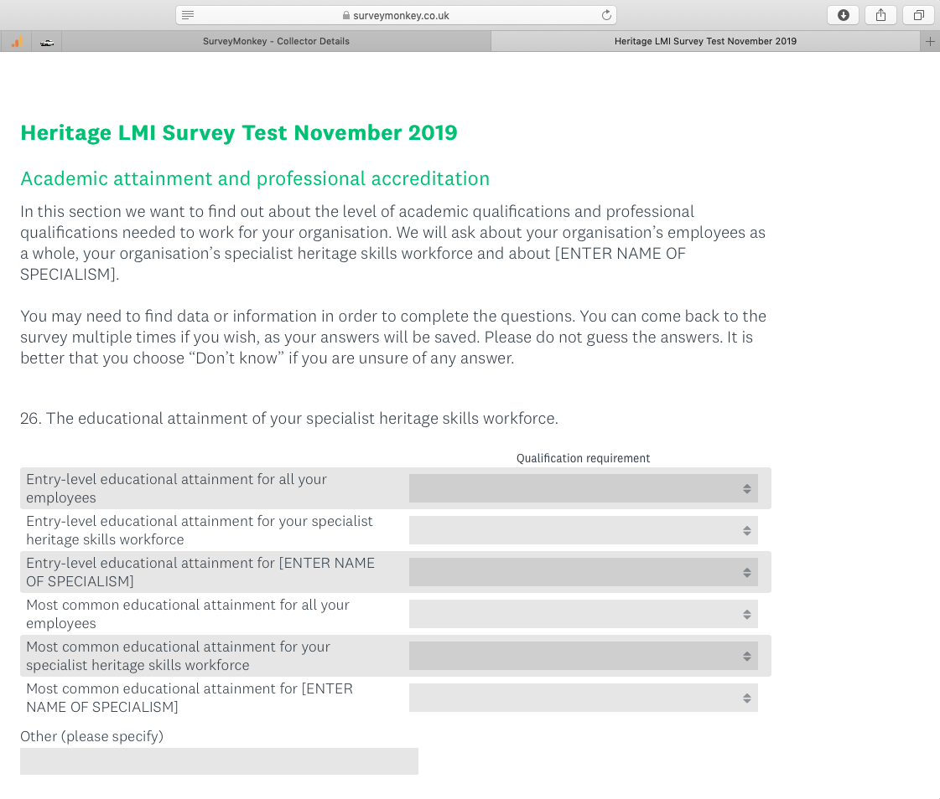

Image 2: To the right of the items to evaluation is a single column of dropdown menus next to each row. Each dropdown menu should include the answer options listed under Question 1 or Question 2 of Module 4 relevant to your respondent’s home nation. As you will have only a single column, the dropdown in it will be the same for each row.

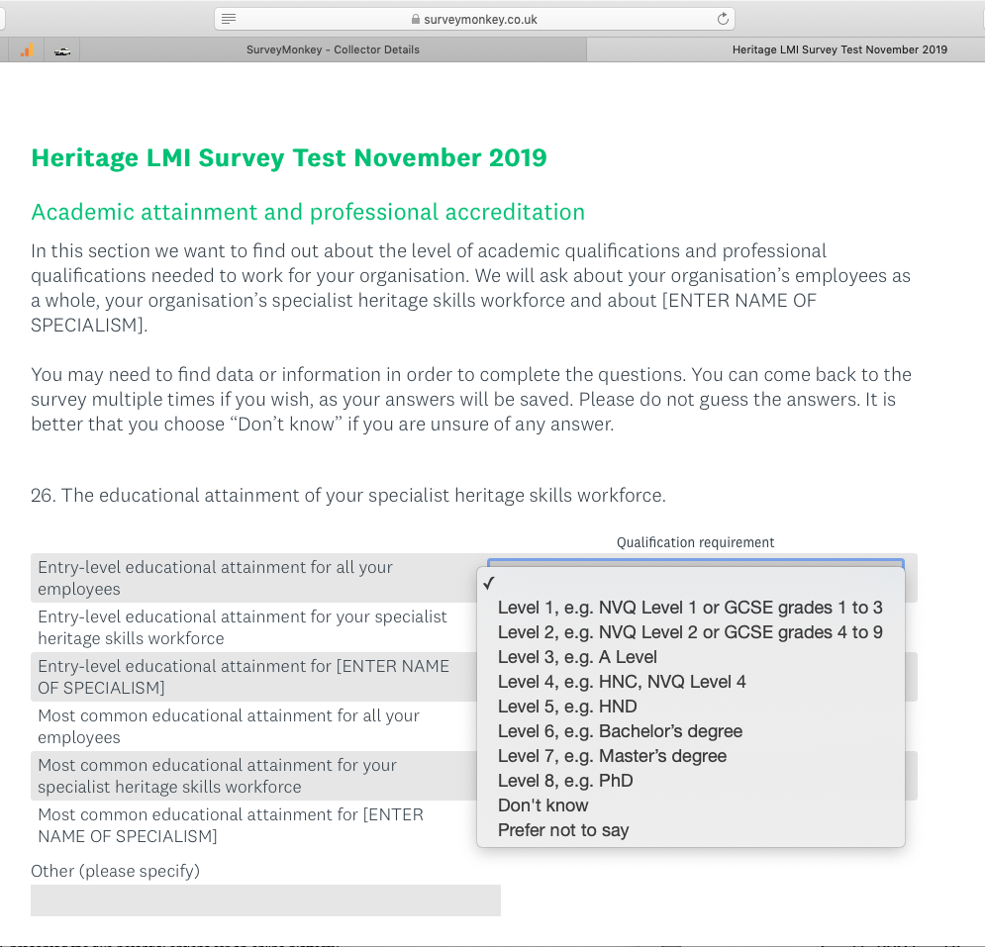

Image 3: Your respondents then choose the appropriate answer for each item on the left-hand column from the corresponding dropdown menu to the right.

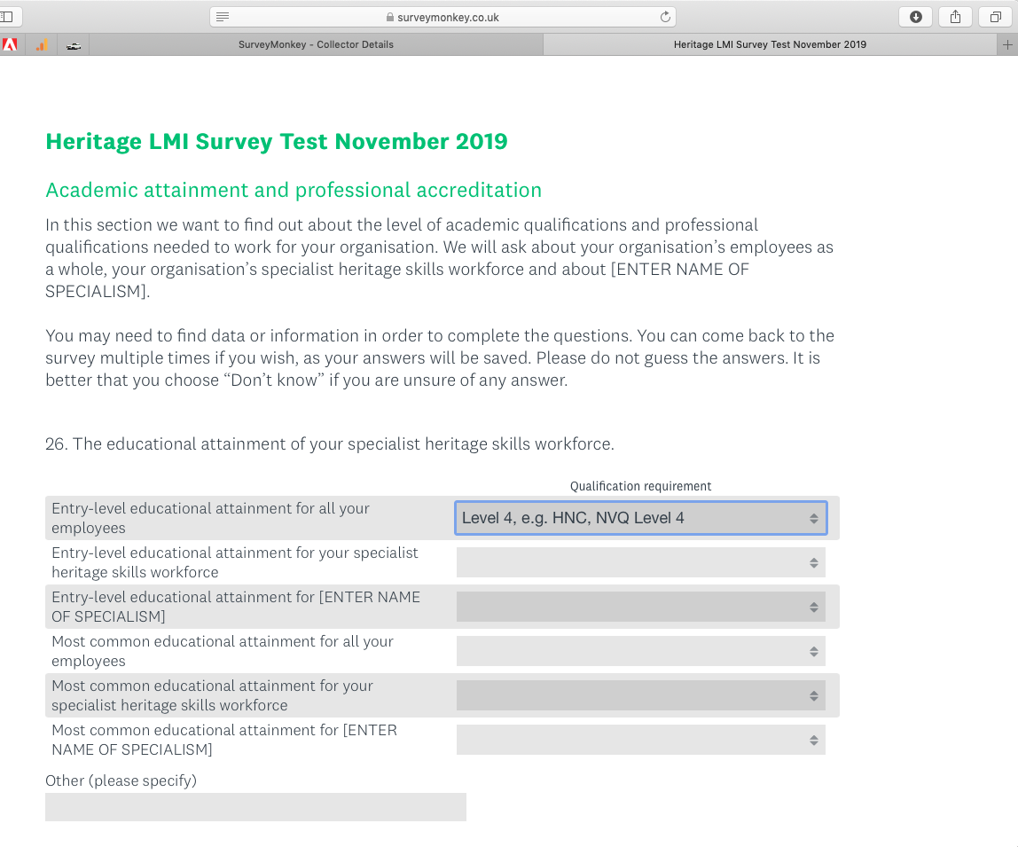

Image 4: And this is how the question will look when all items to be evaluated have an answer.

