Episode 7: Around Rant Score
In this episode you might come across some new words. Here are some we thought were interesting:
Cupola – a dome (round roof) on top of a building
Grandiose – very large or wonderful, or intended to seem great and important
Mandatory – something that must be done, for example ‘The teacher made doing homework mandatory’
Italianate style buildings – buildings designed in a traditional Italian style
Fruiterer – a person who sells fruit in a shop or market
Florist – a florist is a shopkeeper who arranges and sells flowers and sells house plants
Haberdashery – a shop that sells items for sewing, such as buttons, zips, thread, cloth, and pins

As you are listening:

Jot down things you find interesting…

What types of shops are mentioned in this episode?

Discuss your answers as a class.

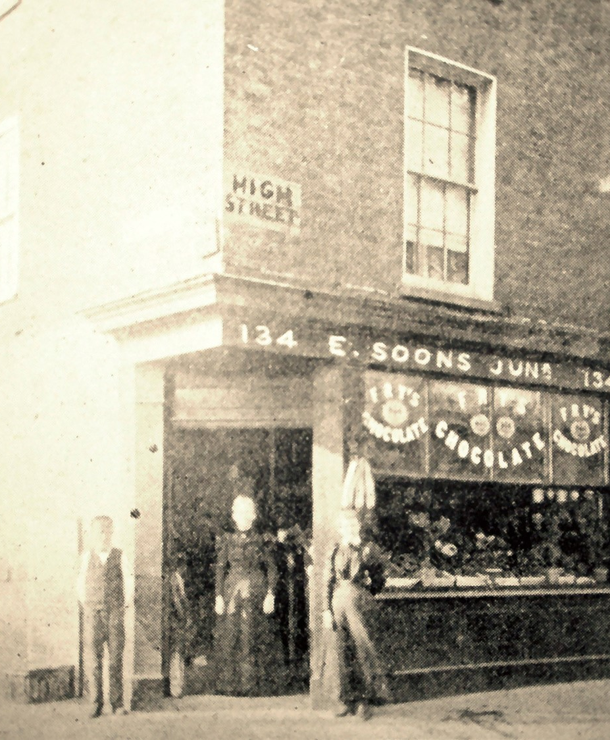

Soons shop on Lowestoft's High Street

Soons was a 'traditional corner shop' which sold sweets.

Here's a list of shops you could have once found in the High Street: a baker, a bookshop, a butcher, a cobbler, a confectioner, a fancy draper, a fishmonger, a florist, a fruiterer, a haberdashery, a hatter, an ironmonger, a plumber, a taxidermist, a tailor, a tobacconist.

In pairs discuss how many of these types of shops are still around today?

Then make a list of shops you'd find on a modern High Street:
© Ivan Bunn Collection

Write a list poem of your favourite shops and what you might buy there.

Example:
Now & Then Shopping List
I went to the florist to buy bunch of tulips for Mother's Day
I went to the hatter to buy a school cap for the new term
I went to the butcher to buy sausages for tea
I went to the haberdashers to buy some yarn to darn my socks
I went to the sweet shop to buy jazzies, chocolate mice and sherbet lemons

