Episode 3: The Oldest House?
In this episode you might come across some new words. Here are some we thought were interesting:
Dwelling – a house or flat or other place where people could live
Parapet – a low protective wall along the edge of a roof, bridge, or balcony
Temperance – not drinking alcohol
Emporium – a large retail store selling a wide variety of goods
Pawn Shop – a place to borrow money in return for depositing an article, for example jewellery
Wholesale – to buy a lot of one item (usually shops do this and then sell the items for profit)
Awning – a sheet of canvas or other material stretched on a frame and used to keep the sun or rain off a shop front
Storey – the different levels of a building, for example first floor, second floor

As you are listening:

Jot down things you find interesting…

What types of shops are mentioned in this episode?

Discuss your answers as a class.
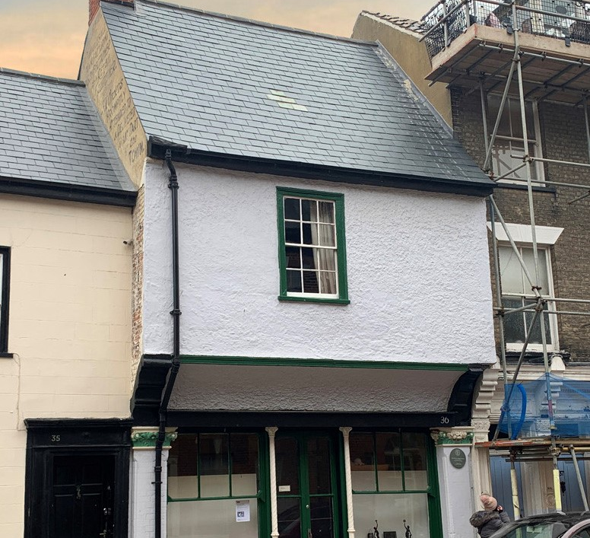
No. 36 High Street, the oldest house on the High Street
© Dean Parkin

This house has stood in the High Street for over 500 years — imagine all the memories that the house would have!
Here are five questions about the house. Answer them in a sentence (no one word answers!).
Put your responses together, line-by-line, create a poem about the oldest house.

1) What would the house say? The house says........

2) Something colourful about the house. In the house there's a.......

3) Something that was lost in the house. 'Under the floorboard...' or 'In the back of a cupboard...' or 'Up in the attic......

4) Something secret about the house. The secret of the house is.........

5) What does the house dream of? The house dreams of.........

