Episode 2: The Vicarage
In this episode you might come across some new words. Here are some we thought were interesting:
Census – an official count or survey, especially of a population
Imposing – grand and impressive in appearance
Grandioso – impressive and imposing in appearance or style
Gentrification – when a poor area is changed by wealthier people moving in, improving housing, and attracting new businesses
Confectionary – sweets and chocolates
Tobacconist – a shopkeeper who sells tobacco and other products used by smokers
Taxidermist – a person who stuffs animal skins, often making them look life like

As you are listening:

Jot down things you find interesting…

What types of shops are mentioned in this episode?

Discuss your answers as a class.
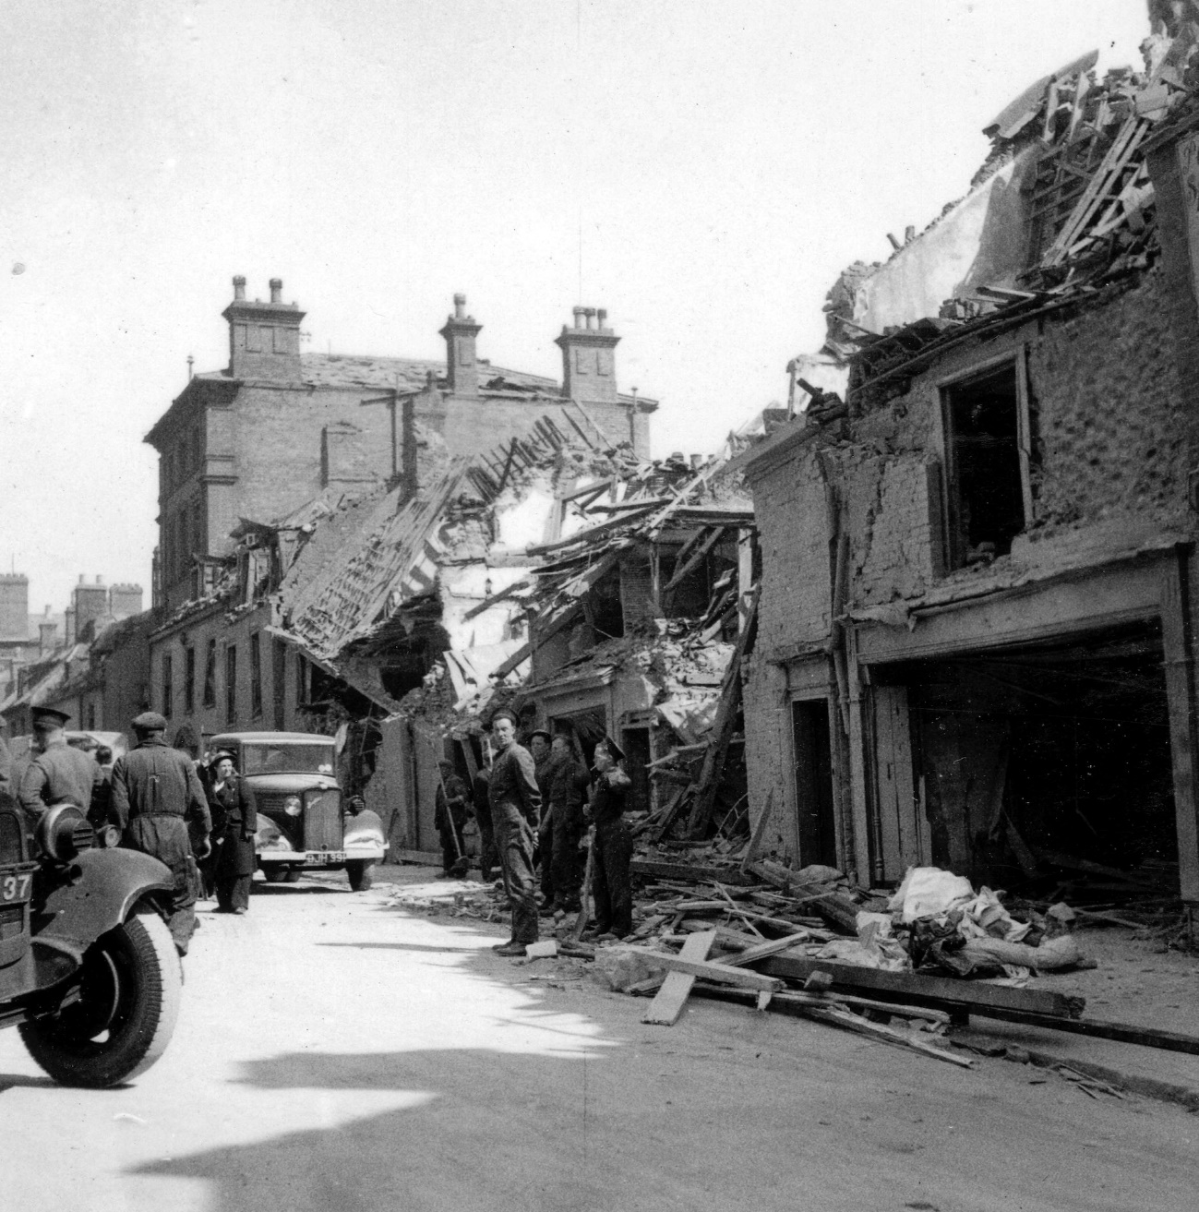
Lowestoft's High Street the day after a major bombing raid in 1943
© Jack Rose Collection

The raid occurred at 9pm on 12 May 1943. Sadly, 32 people died, 51 were injured and 50 houses had to be demolished.
What words would you use to describe the damage?

There's a soldier looking towards the camera — what were his thoughts?

Write a poem about the scene and the feelings of the people clearing up the wreckage.

