Headstone and footstone of the tomb of Scipio Africanus, St Mary's Church, Henbury, Bristol

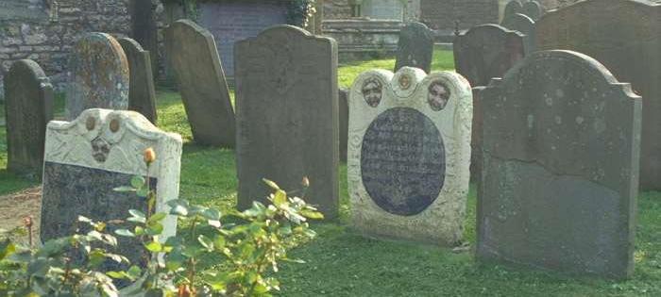
Photograph taken 14 October 1999 © Historic England Archive/Mr Cyril N. Chapman LRPS ref: 379142

For hundreds of years, Bristol was inextricably linked to the slave trade. As early as the 12th century, ships sailing from the port to South Wales and to Ireland routinely carried children to be sold in Ireland. It was with the beginning of the "legal" transatlantic slave trade in 1698, however, that the trade took off, many Bristol merchants making huge sums from the exploitation of enslaved African people in the New World.

The conditions under which these enslaved men, women and children were forced to work led to nearly one third of enslaved Africans dying within three years. Consequently plantation owners required a constant supply of workers captured and transported from Africa - an extremely lucrative "business" for the slave merchants. Bristol's location on the Atlantic side of Britain also aided its participation in the slave trade. For outwardly respectable merchants 'out of sight was out of mind'; their lust for money overcame any doubts they may have had about the moral legitimacy of the trade.

Although most enslaved people were forced to work in the New World, a significant number were brought back to Britain as "status symbols" for their wealthy owners. Although these individuals tended to be treated far better than their counterparts working in the plantations, they were still generally regarded as little more than "pets" or curiosities.

One such British slave was Scipio Africanus, who is buried in Henbury churchyard and who has come to represent all those who suffered as a result of the slave trade, particularly as a result of the Bristol connections. Scipio is hugely important in Bristol's history since his is one of the few known burial places in all of England of an enslaved man or servant from Africa.

Of Scipio's life, all we know for certain is what is carved on his tombstone. He was enslaved or a servant in an aristocratic household, his real name was replaced with a joke name from the white man's antiquity (the original Scipio Africanus was a Roman Emperor). The evidence of his tombstone suggests he was treated with some affection, became a Christian and died at about the age of 18.

Myrtilla's grave in the Church Yard, St. Lawrence Church, Oxhill, Warwickshire

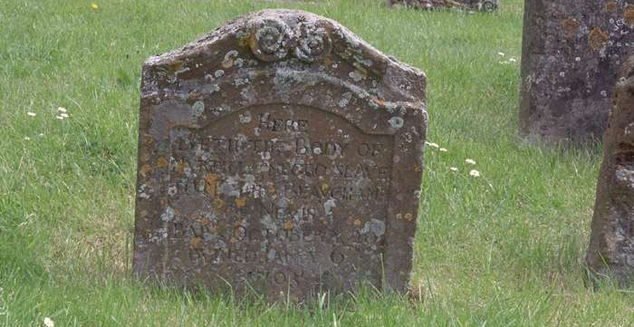
Photograph taken 31 May 2002 © Historic England Archive/Mr David Morphew ref: 307268

This is situated on the south-east side of the Church, and having been restored in 1969 is now easily readable.

“Here lyeth the body of Myrtilla, negro slave to Mr. Thos Beauchamp of Nevis. Bapt. Oct. ye 20th. Buried Jan ye 6th, 1705.”

Mr. Thomas Beauchamp of Nevis is believed to have been a sugar planter, but when or why he came to Oxhill is not known. He is believed to have married one of the twin daughters of the Rector of Oxhill, Nicholas Meese, although no record of this marriage has, as yet been found. However Nicholas and his wife Jane had twin daughters baptised in May, 1677, named Margaretta and Perletta. These names are comparatively unusual, and occur at no other time in the registers. However, Margaretta Perletta, infant daughter of Mr. Thomas Beauchamp and his wife Perletta, was baptised in June, 1706 and buried 1710. Of Perletta’s twin sister no more is known, but it would seem to be a reasonable assumption that Perletta Beauchamp was in fact the daughter of Nicholas Meese, the more particularly as her infant daughters' memorial slab is in the chancel alongside slabs to other members of the Meese family.

Four children were born to Thomas Beauchamp and his wife whilst they were in Oxhill - Thomas, baptised March 8th, 1705, Margaretta Perletta (see above), Robert, baptised September 11th, 1711, and Letitia, baptised October 1714. This is the last entry relating to this particular family in Oxhill, and extensive enquiries elsewhere have elicited no further information.

The parish records note the baptism and burial of the young negro slave, Myrtilla, for example “buried today a young negro girl belonging to Mrs. Beauchamp”. There is also the baptism of one Will Archus “an adult male black” recorded for the year 1700, and in the registers for the parish of Idlicote, January 1st, 1690, the baptism by Nicholas Meese of a young Black girl “belonging to ye Lady Underhill” (Margaret Lucy). As Nicholas Meese was Rector of both Oxhill and Idlicote at that time, it is possible that Mr. Beauchamp either gave or sold Margaret Lucy to Lady Underhill.

However, as he obviously ensured that all three enslaved people in his charge were properly baptised, and that Myrtilla was decently buried, with a headstone to mark her grave, we may perhaps assume that he at least cared for their spiritual wellbeing. How a young girl from the sunny Leeward Islands would view Oxhill in the early-18th century cannot be imagined. There is no evidence as to the cause of her death. It may well have been that she was unable to stand the rigours of our climate.

http://www.oxhill.org.uk/StLawrenceChurch/SlaveGrave.htm

Sambo’s grave and the house where he died

Photograph taken 19 September 2006 © Historic England Archive/Lorna Freeman ref: 182197

Up until the 18th century, Sunderland Point was the main port serving Lancashire. Trade was undertaken with the West Indies involving cotton, rum, sugar and to a lesser degree, enslaved people.

Sambo, it is thought, was a young man who had been enslaved, possibly bought at auction, and taken into service by either a sea captain or a merchant with the idea of using him as a personal attendant. How old he was, how long he served and the manner of his death are all unknown today, but there are two theories as to what happened. One states that he was the sole survivor of a shipwreck, perishing shortly after being washed ashore. This would appear to be a verbal tradition, not appearing in print until fairly recent times. A more traditional version tells us that Sambo's master, having being called away unexpectedly on urgent business, left his charge to wait for him in or around Sunderland. The lad then either perished through the cold, or fearing that he had been abandoned forever on an alien shore, died of a broken heart.

Sambo was buried in an isolated field close to the sea shore, his grave being initially marked by a plain wooden cross. Its splendid isolation however, combined with its associated legends started to draw a large number of curious visitors. One, the Reverend James Watson, a retired headmaster from Lancaster, visited the site in 1795. He was so moved by the story and the aura of the area that he collected a shilling from any visitor willing to donate. With this money he had a proper memorial stone carved complemented by a brass plaque bearing the following inscription

Here lies , Poor Sambo, A Faithful Negro who (Attending his master from the West Indies)
DIED on his arrival at SUNDERLAND
Full sixty years the angry Winter's wave
Has thundering dashed this bleak and barren shore
Since SAMBO's Head laid in this lonely grave
Lies still and ne'er will hear their turmoil more
Full many a sandbird chirps upon the sod
And many a moonlight elfin round him trips
Full many a summer's sunbeam warms the clod
And many a teeming cloud upon him drips
But still he sleeps-till the awakening sounds
Of the Archangels Trump new life imparts
Then the GREAT JUDGE his approbation founds
Not on man's color but his worth of heart
James Watson Scr. H. Bell. del 1796

http://www.bbc.co.uk/lancashire/content/articles/2007/03/28/abolition_sambo_grave_feature.shtml

This Information Sheet relates to the Teaching Activity: What can Victorian buildings tell us about how the Victorians thought?

