These resources and the calendar from which they grew were designed to provide a more accurate picture of the North East by adding to it the presence of African residents and visitors and their achievements. The hope is that as well as being more accurate it would challenge narrow thinking, stereotypes and racism and make the North East a happier place for all. We needed to challenge ourselves in many ways on our journey and in sharing these we hope to prepare you for the challenges you may receive from your students. We hope you find it useful and that you will return to it when those challenges arise.
Why African?
Firstly, why focus on Africans and how do we know who is African? The focus on Africans is just one step in the progress towards greater inclusion and historical truth. The focus on Africans also arose from both a negative and a positive. The negative is that this group, along with Gypsies, Roma and Travellers and the Muslim community, experience the greatest racism and exclusion. The evidence is there in the ‘Stop and Search’ figures, the impact of Covid 19 figures and in the figures for school exclusion. Therefore, challenging this racism and exclusion with all, especially with growing and receptive minds is critical. The positive is that the first recorded African community in England is in the North East and Cumbria, and that the greatest orators against enslavement, such as Frederick Douglass, spoke many times in the North East and Cumbria against enslavement. We have so much information to share that challenges the image that the North East is exclusively white or monocultural.
Strictly speaking we are all Africans as the archaeological evidence suggests that our common origin was in East Africa. But we have used the term for those who both saw themselves, and were seen, as African. They may, like Frederick Douglass or Mary Ann Macham have had one white parent. They may like Martin Luther King Jr and Mohammad Ali be born in North America or like Celestine Edwards and Learie Constantine in the Caribbean.
Students may need help to understand that Africans may be citizens and residents of any country and may be any skin tone. Ellen Craft escaped enslavement because she could pass as white as well as due to her courage, determination, support and good luck. There may be value in asking students to note how many African school cleaners and how many African head teachers they know of in the North East in order to identify discriminatory outcomes. But we need to be careful that as well as understanding the reasons for this discrepancy they do not move to simplistic labelling. There will be people born in Africa who are white and are not perceived or treated as African. There will be descendants of Africans who are perceived as white and only latterly find out their complex ancestry, as in the descendants of John Kent.
Perhaps students could be encouraged to seek from the person’s own words, on social media or in print, how they identify. Older students may be able to add to this the external aspects of identification, understanding how the person is perceived and treated by others. Asking other people, including our own students how they see their own identity is a good starting point though most people have multiple histories and identities. For more information see Saini, A. (2019) The Return of Race Science, London, Harper Collins
To complicate the issue, people may use ‘black’ meaning African or ‘black’ meaning a person of colour or/and a person likely to experience racism, thus including South and East Asians. As we did not have the resources to focus on all people of colour and to avoid confusion we have used the term African and of African descent to clarify our particular focus.
Racism
Those deemed African often experience racism through enslavement as in Equiano, as state and individual racism as the careers of Jimmy Durham, Ira Aldridge, Celestine Edwards and Paul Robeson indicate. To make the best use of these resources, discussions on racism, albeit in age appropriate ways, as in the Usborne books in the linked Children’s Book List, is essential. A particular challenge is to assist students to recognise racism, be aware of its extent and consequences, while centering the responsibility of all to resist and challenge it from their different positions. Being bullied for diverse reasons can be used as a bridge in understanding though it can slip into a barrier where the child or adult uses their experience to minimise that of others. Books to assist adults understand and tackle racism include:
Akala (2019) Natives: Race and Class in the Ruins of Empire, Two Roads
Clarke, M.B. (2021) When we say Black Lives Matter, London, Wren and Rook
Diangelo, R.(2018) White Fragility, London, Allen Lane
Gal-dem (2019) I will not be erased, London, Walker Books

Enslavement
The 24 lives recounted in this resource range from Roman times to the 21st century and include achievements in nine spheres. In using these resources we need to be aware that our focus on enslavement does not dominate or detract from other stories. While the vast majority of those in this booklet were directly affected by racism, including Ishmael Cummings, Martin Luther King Jnr and Archie Sibeko, only four directly experienced enslavement (Macham, Equiano, Craft and Douglass) with the latter three actively fighting to end enslavement. How we include this teaching and learning on enslavement is critical.
The guidelines from the Historical Association Teaching Fellowship (2019) https://www.history.org.uk/higher-ed/categories/905/module/8712/podcasts-britain-and-transatlantic-slavery reinforce our good practice in bringing to the fore the achievements of the enslaved and freed Africans in ending enslavement, as in Equiano and Douglass as well as the achievements of Africans prior to enslavement and subsequently (Prevatt Goldstein, 2021). Enslavement also had two major legacies, economic and ideological as it made necessary and embedded the concept and practice of racism.
It is important that teaching on this topic is both age-related and takes into account that it is likely to have a different effect on the descendants of those enslaved and the descendants of those far removed from this experience (see chapter by Prevatt Goldstein in the forthcoming book ‘Whose Heritage’ eds. Ashley, S. and Stone, D. 2022). Consistent attention to language and the use of the terms enslaved African, enslaver, enslavement and the Transatlantic Trade in Enslaved Africans (TTEA) are important as they accurately portray the reality that human beings were actively enslaved. The terms slave and slavery suggest that a ‘slave’ was a type of human being and slavery an existing practice without active profiting practitioners and countries. The latter terms neutralise and obscure the reality.
Ordinary Lives
As in the risk of focusing only on enslavement and the ‘victim’ status of African people, there is a risk in focusing only on high achieving Africans or those of African descent. It is a necessary antidote to racism and exclusion, yet our teaching needs to demonstrate a valuing of each other as human beings, rather than high achievers or model citizens. The public displays of racism (and its rejection) when the footballers of African descent missed penalty goals in Euro 2020 (Olusoga, Guardian 13.07.2021) and the essays in the publication ‘The Good Immigrant’ (Shukla, N. ed. 2016) demonstrate these pitfalls. In this resource creative work can be done on the lives of William Fifefield, Mary Macham, the unknown young black servant and John Kent, imaginatively filling in the gaps of our knowledge of ordinary lives. Further information can be found in the books for children, in the references listed on this website and in:
Fryer, P. (1974, 2018) Staying Power, The History of Black People in Britain, London, Pluto Press
Fryer, P. (1993) Aspects of British Black History, London, Index Books
Olusoga, D. (2018) Black and British: A Forgotten History, Macmillan, London
Prevatt-Goldstein, B. ed. (2021) African Lives in Northern England, Newcastle, New Writing North
This resource demonstrates that Africans, as with many other diverse groups, not only lived, visited and contributed to our region but their lives are embedded in the fabric of our region, there in the stones from Hadrian’s Wall at Burgh-by-Sands, Cumbria, in the Black Gate, Newcastle, in the Royal Victoria Hospital, Newcastle, in Newcastle City Hall, in Kings Hall, Newcastle University, in homes, churches, meeting rooms and assembly halls across the region. African descendants contributed then and continue to contribute (Prevatt Goldstein, 2021). The thoughtful use of these resources can also challenge racism and promote appreciation and respect for diversity then and now.
These resources have been produced by the African Lives in Northern England Project.
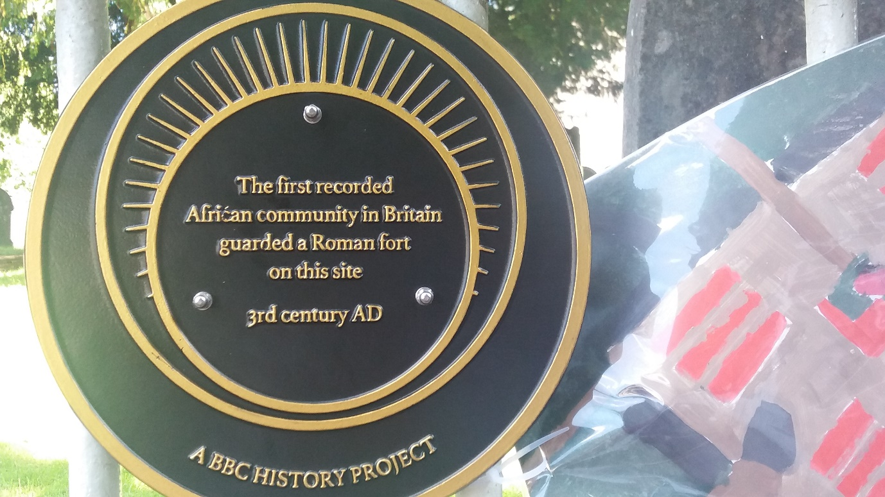
Image of plaque to commemorate the first recorded African community in Britain courtesy of Beverley Prevatt-Goldstein

Authors of the School Resource: African Lives in Northern England

Sean Creighton, Historian of North East slavery, abolition and the black presence
David Faulkner, Co-ordinator, Waka Waka Africa North East
Bill Griffiths, Head of Programmes and Collections, Tyne and Wear Archives and Museums
Barbara Kentish, Westminster Justice and Peace
Don O’Meara, Archaeologist, Historic England
Austin Oshegbu, Trustee: North East England African Community Association (NEEACA)
Pat Poinen, Chair: NEEACA, Equalities Activist
Beverley Prevatt Goldstein, Coordinator, African Lives in Northern England Project, Equalities Activist, member of NEEACA and Culture Against Racism
Iyamide Thomas, Historical Researcher / Curator of 'The Krios of Sierra Leone' exhibition, Museum of London Docklands.
Sue Ward, News Bulletin Editor, Newcastle Antiquaries

We would like to thank all those who reviewed this resource and who contributed their knowledge and insights particularly Rosa Lores-Prevatt of Greenleaf Primary, London, Roshan Nnaji of St Mary’s Catholic School, Newcastle and the volunteers of the Breaking Chains Exhibition, Old Low Light Heritage Centre, North Shields. We are appreciative of this opportunity provided by Historic England and the Society of Antiquaries of Newcastle upon Tyne to share with our young people the contributions of people of African descent to our northern history.

